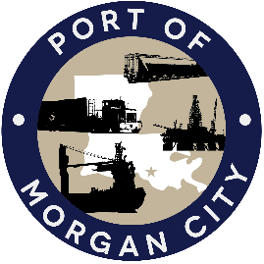

NOTICE OF PUBLIC MEETING

MORGAN CITY HARBOR AND TERMINAL DISTRICT

Notice is given that a special meeting of the Board of Commissioners of the Morgan City Harbor and Terminal District (“District”) has been called by Ben Adams, President of the Board of Commissioners, and will be held at 7327 Highway 182, Morgan City, Louisiana on Wednesday, July 23, 2025 at 12:05 p.m. for the following purposes and to take appropriate action thereon, to wit:

AGENDA

- Call to Order

- Roll Call

- Discussion and any action on West Dock Expansion Project, including permit(s) and mitigation

- Discussion and any action on State Project No. 36-P15-23-02 Warehouse Infrastructure (Fire Suppression), including award, agreements, engineering, advertising, construction, payments, change orders and substantial completion

- Adjournment

In accordance with the Americans with Disabilities Act, if you need special assistance, please contact Tori Henry at 985-384-0850, describing the assistance that is necessary.

